**ATAR Physics 11**

**Unit 2**



**Waves**

Waves are periodic oscillations that transfer energy from one point to another.

**WAVES**

* All waves, mechanical and electromagnetic, transfer energy from one place to another.
* A wave is a disturbance which progresses from one point in a medium to another, without the transport of matter. The characteristics of wave motion are:

1. energy is needed to set up a wave.
2. particles in the medium execute relatively small vibrations about their mean positions but suffer no permanent displacement.
3. successive particles perform similar motions but slightly delayed in time (energy transferred as wave progresses).

* A wave can be defined as a regular vibration (periodic oscillation) that transfers energy while the medium (what the wave is made of) itself does not move from one place to another but rather vibrates about a fixed position.

## PERIODIC WAVES

* Disturbances which are single and non-repeating are called pulses.
* Disturbances which are repeated on a regular basis are termed periodic waves.
* The simplest form of vibratory motion is simple harmonic motion (SHM). The oscillations of a pendulum and the vibration of a single particle in a wave motion are examples of SHM.
* A particle vibrating with SHM has the following characteristics:

1. it vibrates about an equilibrium position.
2. at maximum displacement, velocity equals zero.
3. **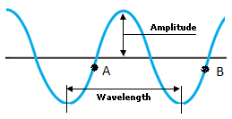**at zero displacement, velocity is a maximum.

**TERMINOLOGY**

Displacement (s): the distance from equilibrium position

Amplitude: the maximum displacement of the wave

Phase: the position and motion at any instant –

points A and B are in phase.

Period (T) time taken for one complete wave cycle

Frequency (f) number of cycles per second (called pitch in music) 

Wavelength (λ) the distance between two consecutive points in the same phase of wave.

Wave velocity (v): the velocity of the disturbance or wave through the medium. 

Compression: maximum forward displacement of particle } associated with

(high pressure region) } longitudinal

Rarefaction: maximum reverse displacement of particles } waves

(low pressure area) }

Crest: maximum vertical (upward) displacement of particles } associated with

Trough: maximum vertical (downwards) displacement of } transverse

particles } waves

Mechanical waves transfer energy through a medium; longitudinal and transverse waves are distinguished by the relationship between the directions of oscillation of particles relative to the direction of the wave velocity.

## TYPES OF WAVES

* **Mechanical waves** are those which require a physical medium e.g. sound and water.
* **Electromagnetic waves**  do not require a medium e.g. light, radio waves.

### Transverse Waves

* Wave motion in which the particles of the medium vibrate perpendicular to the direction of energy transfer.

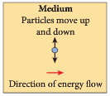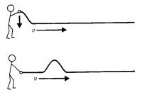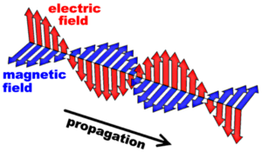

* Below is a transverse wave. On it mark the direction of travel for each of the medium particles indicated (one is done for you)

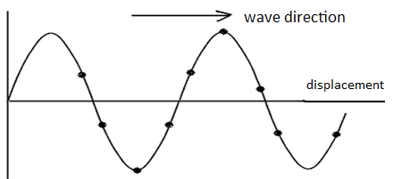

distance

### Longitudinal Waves

* Wave motion in which the particles vibrate left and right in the direction of energy transfer.
* Instead of peaks and troughs, a longitudinal wave is made up of regions of squashed up medium or higher pressure (called a compression) interspersed with regions of low pressure (called a rarefaction).

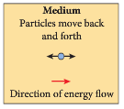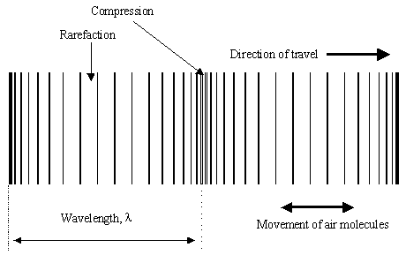

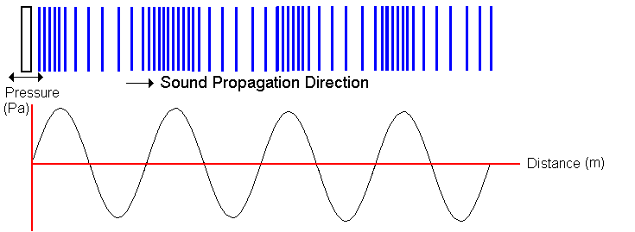**Representing Longitudinal Waves**

* The variation in pressure along a longitudinal sound wave is that of a sine wave as shown alongside.
* However, longitudinal waves can also be represented by showing the variation of a single particle displacement from its mean or average location.

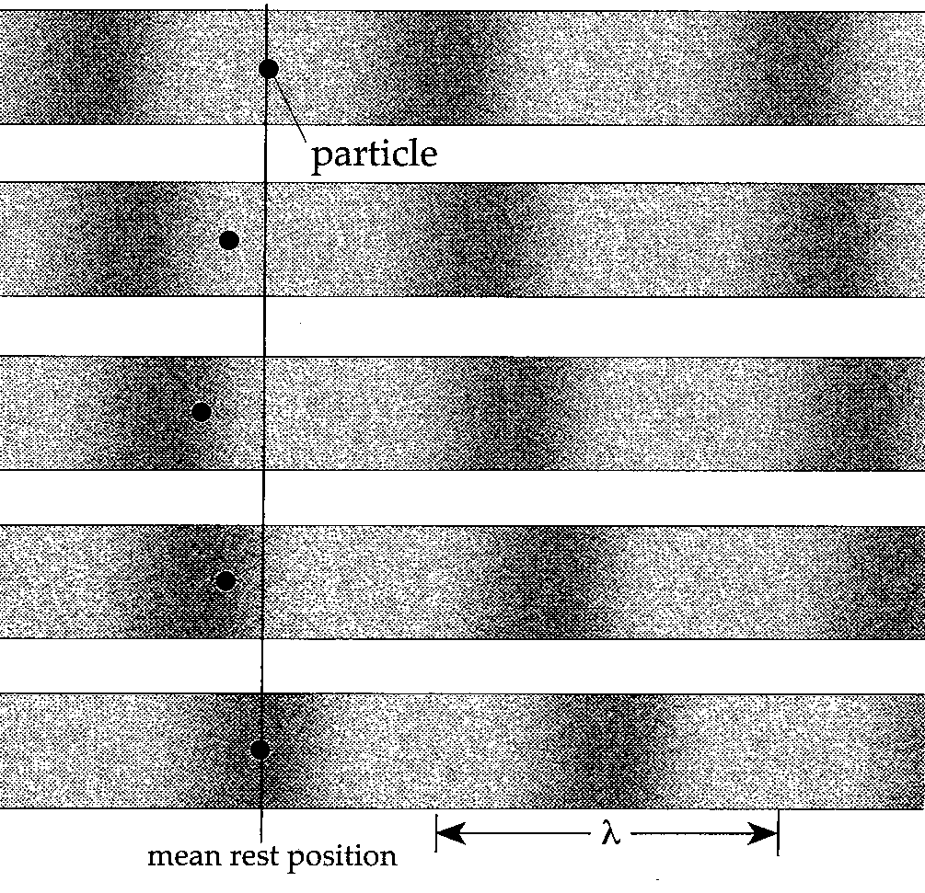

* In the diagram alongside, the motion of a single particle is recorded as a wave passes. Positive displacement is in the direction of the wave (R to L). The particle has zero displacement in the middle of lowest and highest pressure. It has maximum displacement half way between the two (middle strip).
* Consequently a graph to depict this variation in a particle displacement from its mean position must be 900 or a ¼ of a wave shifted from a pressure variation wave.

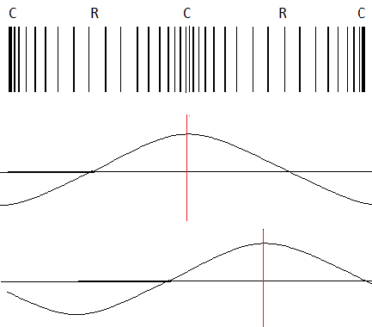

Compression wave

Pressure Wave

Displacement wave

* 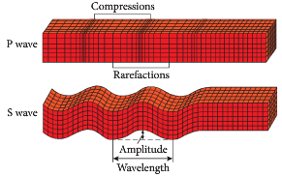*Water is actually a special wave type – a mixture of the two, but is considered transverse in this context.*
* Earthquakes, below the Earth’s surface, spread their energy out in waves.
* The primary wave, P wave, is longitudinal.
* The secondary wave, S wave, is transverse.
* Explain how a mechanical wave is different from an electromagnetic wave and give examples of each.
* Explain the difference between the motion of the particles in transverse and longitudinal wave. Diagrams may help.
* What similarities and differences exist between longitudinal and transverse waves?

**PP 10.1 p 334-7 10.1 Review p 338 WSG p130-2**

Waves may be represented by displacement/time and displacement/distance wave diagrams and described in terms of relationships between measurable quantities, including period, amplitude, wavelength, frequency and velocity

*This includes applying the relationships*



**WAVE GRAPHS**

* A wave can be displayed on a graph as shown below:
* *Displacement /distance graph*  -

This graph shows wavelength and amplitude

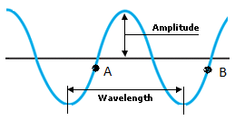

+

Displacement

-

shows many particles -

as if a still picture have been taken of the wave

Distance 🡪

* *Displacement /time graph* Your teacher will draw this graph for you to copy.

This graph shows the period of a wave 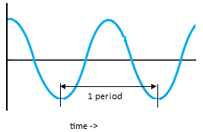

+

Displacement

-

shows one particle only -

as if a video has been

taken of the particle

* Explain why a different type of information is conveyed by a displacement-time graph in comparison with a displacement-distance graph.

**WAVE EQUATIONS:**

* The wave velocity is the velocity with which the disturbance moves through the medium. It is the product of the wavelength and the frequency.



**v = fλ** and **T =** where: v = wave velocity in m s-1

f = frequency in Hz (s-1)

λ = wavelength in m

T = period in s

* 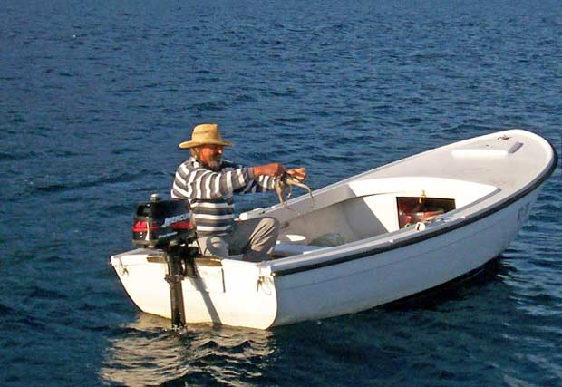A fisherman counts 5 waves passing his anchored boat each 20 seconds (or frequency = ¼ wave sec-1) . He also notes that a wavelength is 2m long.

Calculate the wave velocity.

* Radio 96FM transmits radio waves at frequency of 96.1MHz (at a velocity of 3.0 x 108 ms-1).

a) How long are the waves?

b) What is the wave period?

* Look at the following wave.

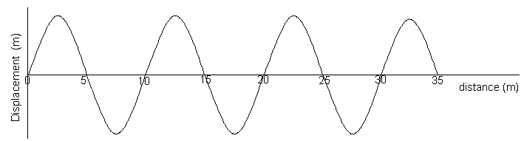

a. What is the wavelength of the wave above?

b. 10 waves pass every second. What is the frequency?

c. What is the time taken for 1 cycle (wave)? That is, what is the period?

1. Calculate the speed of the wave (velocity of the wave)?
2. On the axes below draw **accurately** the same wave as it would appear for the first 0.2 seconds.
3. Look at the following wave that has a velocity of 3.0 x 108 ms-1. Calculate the frequency and then use the chart in your data sheet to determine what type of wave it is.

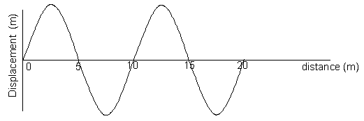

**PP 10.2 p 339-45 10.2 Review p 346-7 WSG p133-4**

The mechanical wave model can be used to explain phenomena related to reflection and refraction, including echoes and seismic phenomena.

## WAVE FRONT

* A wave front represents all particles in the medium which are in the same phase, ie. all the crests (or troughs) or all the compressions (or rarefactions).
* A ray is a line drawn perpendicular to the wave fronts showing the direction of propagation. Each successive wave front is a wavelength apart.

**ray**

## wave fronts

## WAVE BEHAVIOUR

**Reflection:**

* All waves are reflected when they strike a barrier in their path. They are reflected such that they obey the law of reflection: **the angle of incidence = the angle of reflection**.

**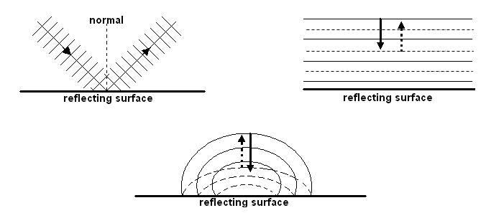**

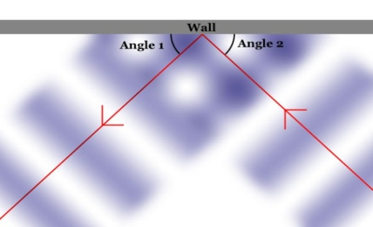

* *As in all waves, there is some absorption during reflection - i.e. not all energy is transmitted on.*
* There are two major types of reflection.
  + Specular reflection is very is very uniform and is why we can see our reflection in a mirror.
  + Diffuse reflection is irregular and explains why a white shirt would reflect all the light falling on it but is unable to show your reflection.

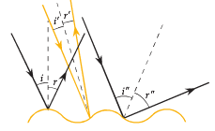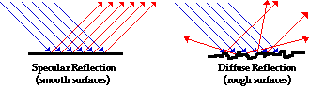

* 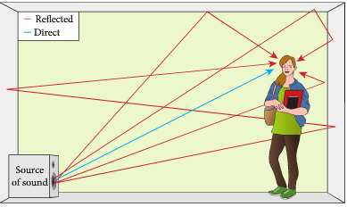Reverberation of sound is when there are multiple reflections of the sound wave. This usually occurs in confined areas where the reflecting surface is hard and smooth and doesn’t absorb the sound wave.
* Reverberations can be annoying in places where sound quality is important. Cinemas, theatres and recording studios take steps to absorb the excess sound.

**Refraction:**

* Refraction is due to a change in velocity as a wave passes from one medium to another with differing wave characteristics (e.g. more dense).
* 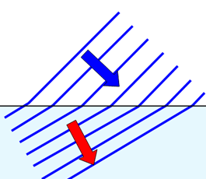The frequency of the wave remains unchanged but due to a change in velocity, the wavelength changes and a bending effect can be observed if the ray enters the new medium at any other angle than 900.

Faster

Slower

* A sound wave of frequency 200Hz travelling at 345ms-1 in air encounters a cooler layer of air where the velocity is 338ms-1. What will the wavelength be in each layer? [**Be aware that f stays constant during the transition]**

* If the wave travels **slower** when it enters the new medium, it bends **towards** the normal e.g. light waves travelling from air into water.

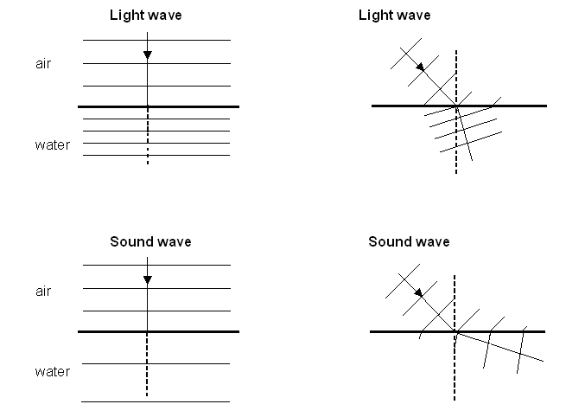

* If the wave travels **faster** when it enters the new medium, it bends **away from** the normal e.g. sound waves travelling from air into water.

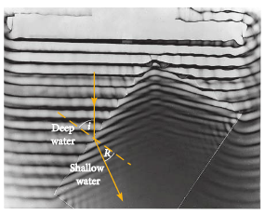

* When water travels through deeper water it moves faster. When it meets shallow water it is slowed down. Therefore, it will refract. It will bend towards the normal and the wavelength will reduce.

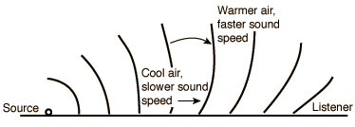

* The refraction of sound explains why sound can be heard over unusually long distances. It is probably unusual for sound to travel in straight paths in the atmosphere due to variation in density.

Density is not the only determining factor of speed of sound – elasticity of medium has an effect.

**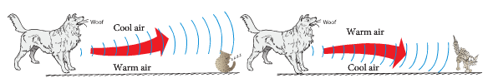**

* Carbon dioxide is heavier than air. An experiment is set up which has a layer of carbon dioxide in a large container with a layer of air on top. The speed of sound in the carbon dioxide is 270 m s-1 and in the air, 340 m s-1. A 450 Hz sound wave travelling through the air strikes the boundary between the two gases at an angle of 400. Find the wavelength in each gas.

**Diffraction:**

* Diffraction is the bending of waves as they pass through an opening or around the edge or edges of an obstacle.
* [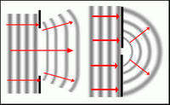](http://2.bp.blogspot.com/_Swc-yt6AW9w/TUql2Nt1F4I/AAAAAAAAAA0/VVdV2CA5iRM/s1600/Diffraction.pn)The amount of bending depends on the opening. If the wavelength is about the same as the opening then maximum diffraction will occur.

**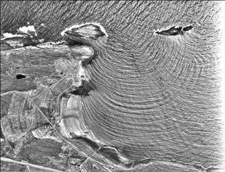**

* 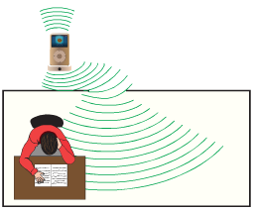This helps to explain why you can hear someone through a door (wavelength of sound similar to width of a door) but you can’t see them (wavelength of light very small).
* In addition, higher frequency sound waves have shorter wavelengths sod they will diffract less than lower frequency sound waves as lower frequency sound waves have longer wavelengths.

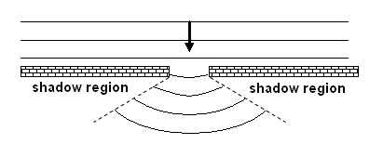

**There is no movement in**

**the shadow region and**

**the size of the shadow**

**region is determined**

**by the width of the opening**

**and the wavelength. The**

**closer they are, the less**

**shadow region.**

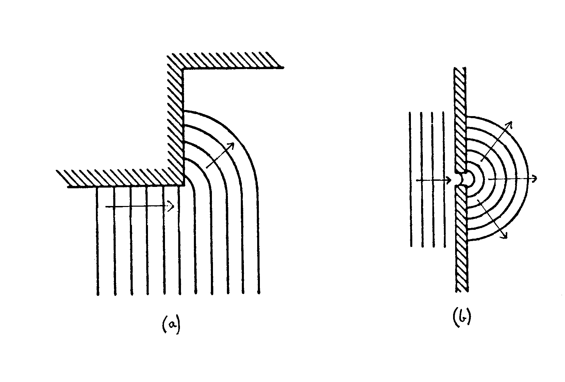

* Diffraction can also occur around corners. Since sound has a much longer wavelength than light, we are able to hear around corners, but not see around corners.

**A Summary of Wave Behaviour**

|  |  |  |  |  |
| --- | --- | --- | --- | --- |
| **Behaviour** | **Cause** | **Unchanged** | **Changed** | **Application** |
| **Reflection** | change in direction as wave strikes a boundary | v, λ, f | direction | echoes and reverberation |
| **Refraction** | change in speed of wave as a result of change in density of a medium | f | direction, λ, v (Snell’s Law) | zones of silence |
| **Diffraction** | change in direction as a result of a wave passing through a gap or around an edge | v, λ, f | direction | hearing around corners and through gaps |

**PP 10.3 p 348-58 10.3 Review p 359-40**

**WSG p137-42**

**QUESTION SET ONE: Waves and Wave Behaviour ANSWERS ON PAGE 31**

1. An umpire blows his whistle when he is at the opposite end of a football ground from you. Estimate the time delay between the moment you see the whistle being blown and when you hear it.
2. a. What does the term “displacement” mean when applied to sound waves.

b. Sketch graphs of displacement versus time for a low pitch graph and a high pitched graph.

1. Do sound waves diffract? If you wanted to try and demonstrate that your answer is correct, how would you try to do this? Include a diagram with your answer.
2. Some examples of waves are sound, radio, water waves, and X-rays. Classify these as either mechanical or electromagnetic waves.
3. A person fishing from jetty notices that the foam float on their fishing line gently bobs up and down as regular waves pass by. The person counts 13 full oscillations of the float in one minute. What is the period of the wave?
4. An example of a longitudinal wave is \_\_\_\_\_\_ An example of a transverse wave is \_\_\_\_\_\_\_\_\_

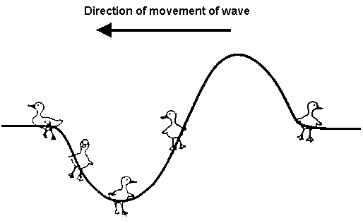Explain the difference between longitudinal and transverse wave.

1. Bridgette is watching some ducklings, which are paddling on a pond, when a wave approaches them. Use arrows to show direction of movement of each duckling at the instance shown on the diagram. If there is no movement, label “no-motion”.
2. Draw a graph to illustrate amplitude and wavelength of a wave.
3. On a calm summer evening the air near the ground is rather cool while higher up it is warmer. Sound travels faster in warm air. Using wave-front diagrams carefully show how refraction of sound can allow the noise from an aircraft to be heard quite clearly at some point far away.

**v = f λ f = v/λ**

bd00173_

TN00908_

The superposition of waves in a medium may lead to the formation of standing waves and interference phenomena, including standing waves in pipes and on stretched strings.

*This includes applying the relationships for*



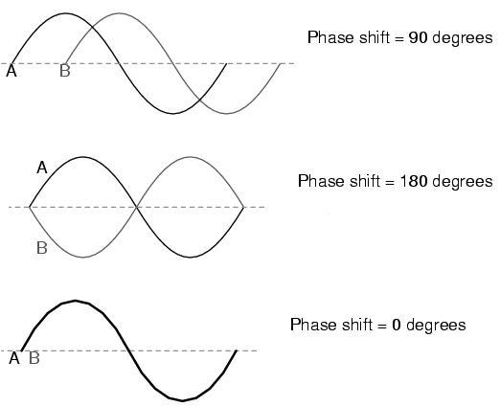**INTERFERENCE OR SUPERPOSITION**

**Phase Difference**

* Two waves are ‘in phase’ if their crests and troughs occur simultaneously. If they are not ‘in phase’, the difference is expressed in degrees.
* What is the phase difference between the following pairs of points on the transverse wave below?

(a) A & D (b) B & E (c) G & H (d) A & E (e) B & H

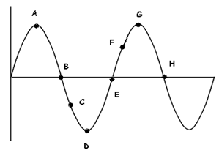

* Superposition or interference occurs when two waves overlap and interfere with each other.
* **Constructive Interference:** a resultant increase in amplitude.

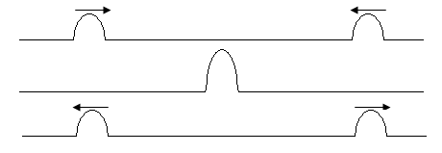

**Reinforcement**

* **Destructive Interference:** a resultant decrease in amplitude.

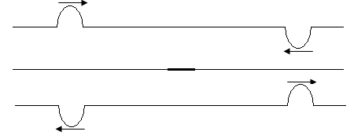

**Annulment**

**Sound : comp + comp = reinforcement = LOUD**

**comp +rare = annulment = SOFT**

* In general, a resultant wave is a mixture of both.
* Waves on the same side are added together. Waves on the opposite side are subtracted.
  + - Draw the resultant wave from these two waves.

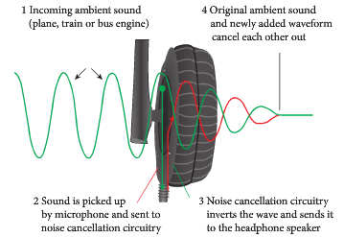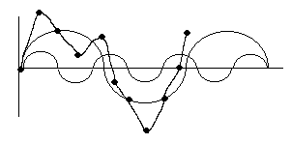

* Noise cancelling head phones work by taking the noise sound wave, inverting it then adding it to the original wave.
* The two waves cancel each other out and quieten the noise.

**Interference Patterns**

* In this diagram two identical wave sources (shown as two apertures) send out waves which by superposition, create an interference pattern as shown. Note the diffraction here.

**HIGH**

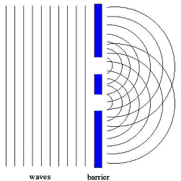

**HIGH**

**LOW**

**HIGH**

**LOW**

**HIGH**

**LOW**

**LOW**

**Diffraction**

Interference pattern for surface water waves

* 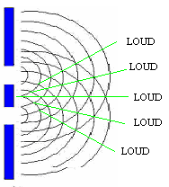Looking closely at how these two waves interact – the straight lines represent the places where **constructive interference** occurs.
* For the central line, the two waves have travelled an equal distance and must arrive in phase all along this centre line. Therefore crests arrive together and troughs arrive together resulting in much vibration – this is **constructive interference**.
* The next straight line above or below, represents two waves which have traveled exactly 1 wavelength apart in distance to get there, i.e. they arrive in phase and again interfere constructively.
* The top (and bottom) straight line represent the resultant of two waves arriving together 2 wavelengths apart, once again interfering constructively.
* Explain why the regions between the straight lines represent regions of quiet.

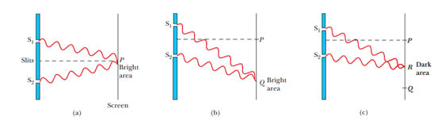

* When two waves arrive at a point they will interfere. If there path difference is equal to nλ, then they will reinforce. If there path difference is equal to (n – ½) λ then they will annul.
* To demonstrate light interference, a laser can be shone onto two slits followed by a screen.

1. What will be seen on the screen?
2. Why use a laser?

* It may be possible to use two loudspeakers wired in phase from an audio oscillator as a demonstration.
* How far away from the closer speaker would a listener be if he is 2.0m away from the further one, listening to an 820 Hz interference pattern. He can hear very little being on the 1st line of destructive interference. [1.8 m]

**PP 10.4 p 361-5 10.4 Review p 366 WSG p143-5**

**BEATS**

* Beats are a special case of interference. Beats occur when two waves of very similar frequencies interfere with each other. The differences in the frequencies are usually less than 10 hertz.

Beat frequency = frequency two - frequency one

fB = |f2 - f1 |

## http://podcomplex.com/guide/physics5.jpg

* When the two waves 1 and 2 are summed, then the wave below is the resultant.
* Note the rhythmic rise and fall in the amplitude of the resultant wave.

[Beats](file:///C:\Resources\Yr%2011%20Physics\Units\Unit%202\10%20Nature%20of%20waves\10.5%20Standing%20waves\beats_en.jar)

* At a rehearsal for a concert a guitar player uses a piano to tune her instrument. She plays a note on the piano which produces a frequency of 440 Hz. When the A string of the guitar is sounded at the same time, she hears four beats per second.

1. At what frequency is the A string vibrating?

1. If the tension on the A string is reduced slightly she hears 1 beat per second when the string is played at the same time as the piano. At what frequency is the A string now vibrating?

**WSG p146**

## WAVE REFLECTION AND PHASE

* In musical instruments, waves travel in strings and in air columns and reflection at the extremities is part of the process of producing musical notes.
* 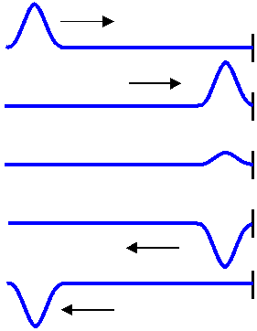**Wave Reflection in Strings:** The type of reflection that takes place depends upon whether the string is tied down (fixed end) or free to “flap”(free end).
* **Fixed End:** The wave reflects upside down – ie 1800 out of phase.
* When the reflection is underway, at the end boundary the

two waves (incident and reflected) must sum to zero

amplitude because the string is tied down. This is only

possible with 1800 phase shift. **This mode of reflection must**

**be going on commonly with stringed musical instruments.**

* 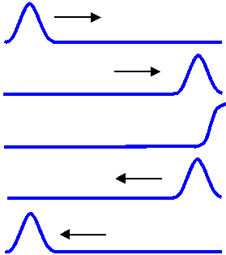**Free End:** The free end rises up & down to represent the wave amplitude. The wave reflects as it approached – ie in phase.

* **Reflection at Air Column Ends:** Sound waves traveling down a tube of air will reflect from a closed end AND from an open end! This obviously is going on with wind musical instruments.
* **Open End:** There is a 1800 phase change forming a pressure node (displacement antinode)
* 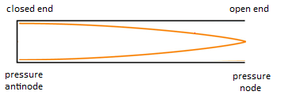**Closed End:** There is no phase change forming a pressure antinode (displacement node)

**STANDING OR STATIONARY WAVES**

* A standing wave is produced when a wave is reflected back opposite to the incident wave and constructive reinforcement occurs.
* The wave is actually moving back and forth along the string, and the ends are continually reflecting the wave. If you look at the string however, the wave does not look like it is moving hence the name **standing wave.**
* The lowest frequency at which a standing wave will be produced is called the **fundamental frequency**.
* The fundamental frequency produces the fundamental wavelength, which is equal to twice the length of the string.
* As the frequency is increased further resonant frequencies will be heard. These correspond to other **harmonics** (or overtones) for that particular standing wave.
* **Nodes** are areas on the wave of minimum displacement.
* **Antinodes** are areas on the wave of maximum displacement.

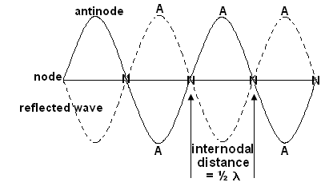

* Two speakers are set up facing each other. They emit sounds of equal frequency and intensity towards each other. A microphone connected to a CRO is used to check the sound intensity level at all points between the speakers.

1. Describe the sound intensity level between the two speakers.
2. What type of wave pattern exists between the two speakers.
3. What is the name given to a point of
4. minimum intensity?
5. maximum intensity?
6. What is the significance of the distance between successive points of equal intensity?

* 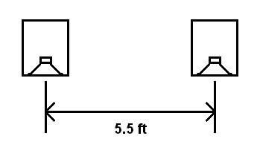Two speakers are connected to a frequency generator and are set up 4.0 m apart. A student walks from one speaker to the other to test the sound that he hears.

1. Is he likely to hear a loud or a soft sound at the midway point? Explain.
2. He walks from the midpoint 1.0 m closer to the second speaker and

encounters two points of minimum and and two points of maximum

intensity. Determine the wavelength of the sound being used.

* The speakers are now set up 2.0 m apart but facing the same direction. Chelsea is standing directly in front of one speaker and can hear no sound while Hannah is at the midpoint. If the sound is travelling at 340 ms-1, determine the frequency.



C

H



**Standing Waves in Strings.** Examples: vocal cords, guitar strings

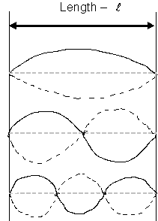 wavelength - λ frequency - f

****

****Fundamental frequency  **f**

**or**

Second harmonic ** 2f**

(First overtone)

**or = λ**



Third harmonic

(Second overtone)  **3f**

**or**

[**http://zonalandeducation.com/mstm/physics/waves/standingWaves/understandingSWDia1/UnderstandingSWDia1.html**](http://zonalandeducation.com/mstm/physics/waves/standingWaves/understandingSWDia1/UnderstandingSWDia1.html)

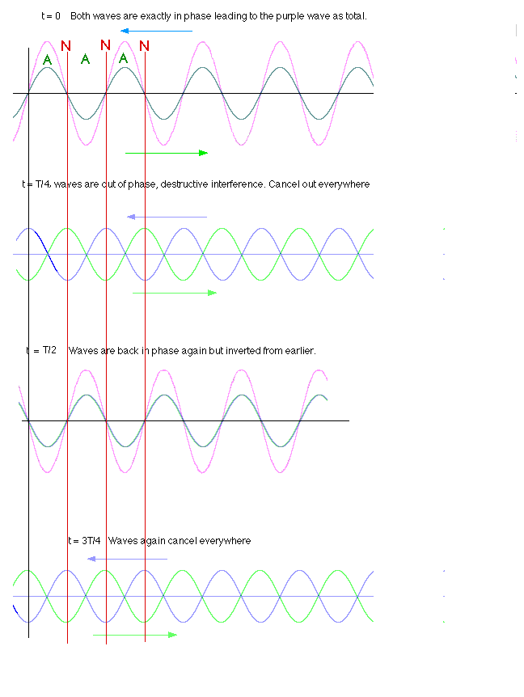

* The speed of waves in a particular guitar string is 425 m s-1. Determine the fundamental frequency of the string if its length is 76.5 cm. (278 Hz)
* The appropriate wavelengths for a fixed length of string, which is fixed at both ends, are shown below. Each mode of vibration is called a **harmonic.**

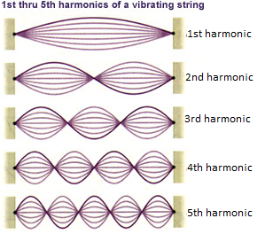 

* Fill in the equations for the 2nd and 3rd harmonics
* When a string is plucked, many of these standing wave vibrations play simultaneously giving rise to very complex wave shapes in the string due to superposition.
* However the 1st harmonic is usually the most dominant and defines the note played.
* The other wavelengths (with reducing amplitudes) which add to it “harmonize” and improve the quality (or “timbre”).
* Pure simple vibrations without harmonics (such as the audio oscillator) sound flat.
* By plucking a string at differing places along the length, various harmonics can be accentuated (antinode where plucked) and others dampened (node where plucked) giving rise to a differing “sound”.
* A guitar string is 56.0 cm long, what is the wavelength for the 1st harmonic (fundamental note).
* What is the pitch of the string if the velocity of the wave in the string is 185.0 ms-1?

* What is the frequency for the 3rd harmonic?

**WSG p147**

## Standing Waves In Sound – An Open Tube

* In an open tube, there is an antinode at each end so the wavelength will be twice the length of the pipe.
* An open ended air column has a fundamental frequency twice as high as a closed air column of the same length.

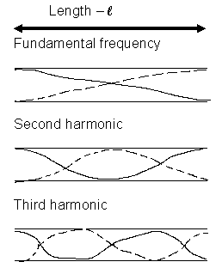

**λ f**

****

**or f**

** 2f**

****

**3f**

**or**

[**http://zonalandeducation.com/mstm/physics/waves/standingWaves/understandingSWDia2/UnderstandingSWDia2.html**](http://zonalandeducation.com/mstm/physics/waves/standingWaves/understandingSWDia2/UnderstandingSWDia2.html)

* *There are two ways of representing waves in pipes – looking at variations in pressure or looking at variations in particle displacement.*
* At the end of an open pipe pressure is the same as room pressure – i.e low pressure. Particles can move freely – i.e maximum displacement.
* There will a pressure **node** and a displacement **antinode**.

min pressure

max movement

max pressure

min movement

min pressure

max movement

open tube – normal air

open tube – with standing wave

* This information can be represented on graphs.

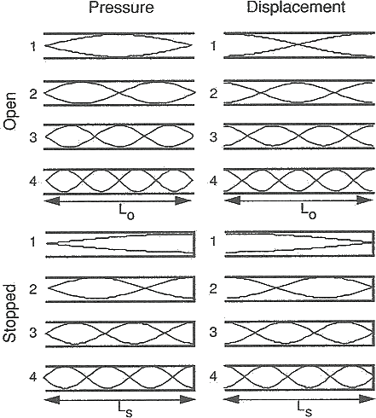

* An open pipe has an effective length of 1.23 m. Calculate

1. the fundamental frequency of the pipe when the speed of sound is 340 ms-1
2. the frequency and wavelength of the second harmonic.

## Standing Waves In Sound – A Closed Tube Example: Vocal tract

* A stationary wave can be set up in an air column closed at one end.

* If a tuning fork is sounded over the mouth of a cylinder, a compression wave will be sent down through the air inside the cylinder and will be reflected back at the closed end.
* When the air column is set into a steady state of motion the note of the tuning fork is greatly amplified (an example of resonance).
* In this stationary wave, there must be a node at the closed end, since the layer of air there cannot move, and there will be an antinode at the open end where the air can move freely.
* The fundamental stationary wave will have only this one node and antinode, as this is the simplest possible mode of vibration. The length of the air column is equal to **one quarter** of a wavelength of the fundamental note.
* As the wavelength equals frequency times wavelength (v = f) it is possible to determine the velocity of sound in the column by measuring the wavelength of the stationary wave corresponding to a particular resonance frequency.

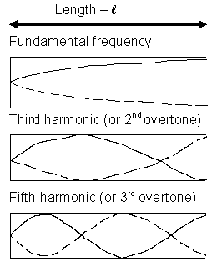

*λ* f

****

**or f**

****

**or 3f**

****

**or 5f**

<http://www.phys.unsw.edu.au/jw/flutes.v.clarinets.html#time>

<http://www.physics.smu.edu/~olness/www/05fall1320/applet/pipe-waves.html> <http://www.acs.psu.edu/drussell/Demos/StandingWaves/StandingWaves.html>

* At the end of an closed pipe pressure is increased – i.e maximum pressure. Particles have very limited movement.
* There will a pressure **antinode** and a displacement **node**.

min pressure

max movement

max pressure

min movement

closed tube – with standing wave

* This information can be represented on graphs.





* Explain why the second and forth harmonics can’t exist in a closed pipe.

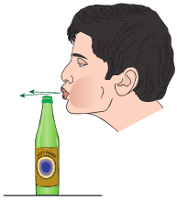**Example**:

If you blow across the top of a coke bottle (30 cm high) it produces a fundamental frequency of 256 Hz. What is the speed of sound in the bottle?

f = 256 Hz v = f

* = 0.3 x 4 = 256 x 1.2
* = 1.2 m = 307.2 ms-1
* A closed pipe is vibrating in its 3rd harmonic with a frequency of 768 Hz. (v = 346 ms-1)

a. What is the fundamental frequency of the pipe?

b. What is the length of the pipe in its fundamental frequency? (Speed of sound in air 346 ms-1)

* Lucy is blowing air over the end of an organ pipe. When she blows softly across the end, a microphone connected to a C.R.O. shows a frequency of 188 Hz. When she blows over the pipe a little harder, a frequency of 376 Hz is shown on the screen. The speed of sound on this particular day is 332 ms-1.

1. Is the pipe open at both ends or open at one end and closed at the other?
2. What is the length of the pipe?

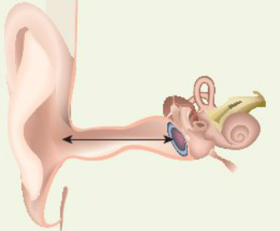

* The human ear can be considered to be a closed pipe. It is most sensitive to sounds of about 5000 Hz. Assuming this frequency corresponds to the fundamental frequency, calculate:
  + The wavelength of the sound.
  + The length of the ear canal of a human.

**PP 10.5 p 367-77 10.5 Review p 378-9 WSG p148-9**

A mechanical system resonates when it is driven at one of its natural frequencies of oscillation; energy is transferred efficiently into systems under these conditions.

## natNATURAL AND FORCED VIBRATIONS

* Whenever an object is struck, such as a tuning fork, and then allowed to vibrate without further interference, its vibrations are called free or natural vibrations.
* All bodies have a natural vibrating frequency and this depends upon their physical characteristics.
* A body can also be forced to vibrate at a frequency which is not its natural frequency. Whenever this occurs we refer to it as a forced vibration.
* A typical example is a tuning fork placed on a bench. The bench is forced to vibrate at the frequency of the tuning fork and the sound is louder because of the larger vibrating surface area.
* The sounding box of a guitar also works in this way. The intensity of the sounds of all musical instruments is enhanced by the effect of forced vibrations.

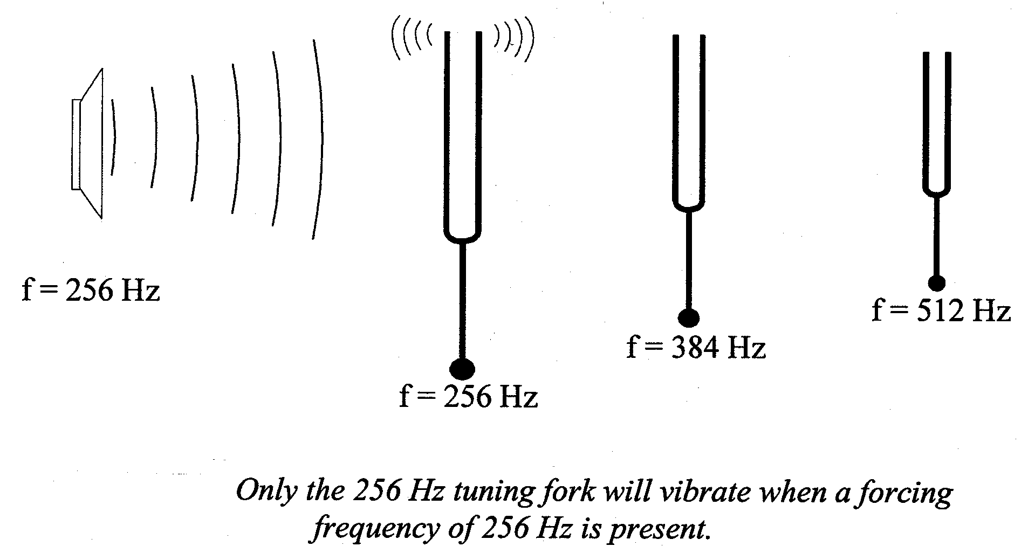

## RESONANCE

* All objects have their own natural frequency of vibration.
* At this frequency an object will vibrate most vigorously.
* Resonance occurs when something forces a body to vibrate at its natural frequency.
* An example of this is a person being pushed on a swing. If applied and natural frequency are equal, the swing’s amplitude will increase.

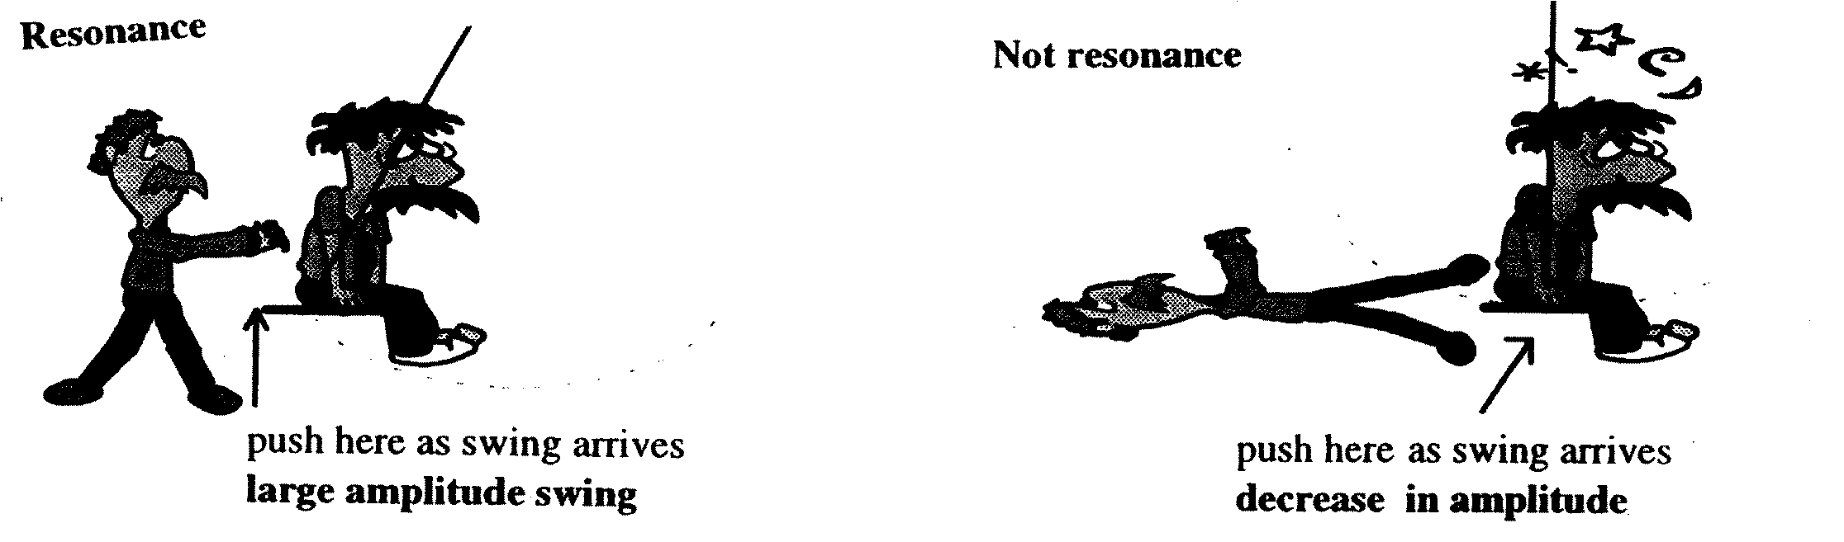

* 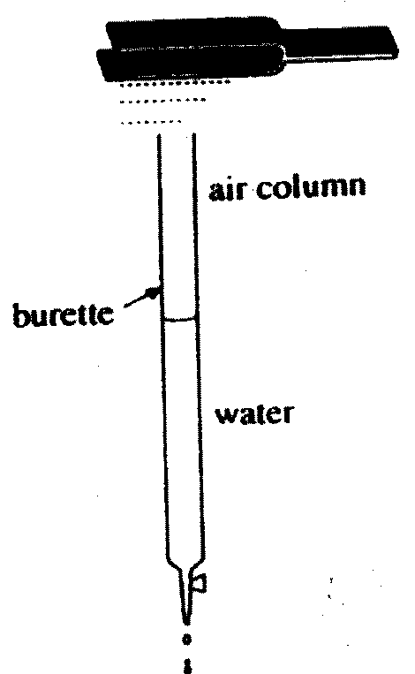 Another example is resonance in organ pipes and similar musical instruments to enhance the vibrations and hence the sound.

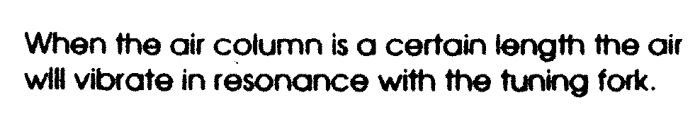

* A few very good singers can cause a crystal wine glass to break when the singer sings a particular note. Explain why this occurs.

**WSG p146**

# REVERBERATION TIME

* Reverberation is the echo effect in rooms.
* Reverberation time is the time for a sound to decrease in intensity by 60 dB. It depends on reflecting or absorbing properties of all the surfaces in the room.
* Soft bumpy & porous surfaces are good absorbers of sound such as the walls in this recording studio. Conversely, hard smooth surfaces are good reflectors.

**QUESTION SET TWO: Standing Waves, etc. Answers page 32 of this workbook**

(Unless told otherwise, use speed of sound in air as 346 m s-1)

1. Why is it important that the currents supplied to two loud speakers in a stereo pair are in phase?
2. 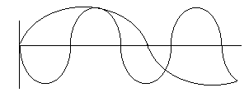Draw a diagram showing a guitar string vibrating in its third harmonic. Label the nodes and antinodes.
3. Copy and draw in the resultant wave.
4. A guitar sting is 0.700 m long and is played so that it vibrates in its fundamental frequency. What would be its wavelength if it were played so as to vibrate in its 5th harmonic.?
5. On a day when the speed of sound is 343 ms-1, a source emits sound of wavelengths 2.80 m and 3.10 m in air. How many beats per second will be heard?
6. 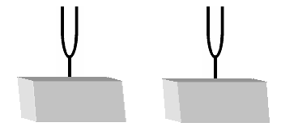Explain the difference between natural and forced vibrations. Include examples with your answer. How is this related to resonance?
7. Two identical tuning forks are set up on boxes open at one side as shown below with the open sides facing each other. The first tuning fork is struck, then stopped from vibrating. A listener notices that the second tuning fork is now sounding even though the two boxes are not touching. Name and explain this phenomena.
8. A large organ pipe is 2.20 m long and open at both ends. Find its fundamental frequency.
9. The shortest length of a tube, closed at one end, which resonates to a tuning fork of frequency 326 Hz is 0.260 m.
   1. What is the wavelength of the note emitted by the fork?
   2. What is the speed of sound in air in this case?
10. A crude whistle can be made by drilling some holes in a cylinder of metal and flattening one end to act as a mouthpiece. The mouthpiece acts as a closed end while the other end can be considered to be open. The instrument is played in a room in which the temperature is 250C.
    1. With all the holes covered the whistle produces a fundamental note of 152 Hz when blown gently. What is the wavelength of the fundamental note?
    2. What is the effective length of the whistle?
    3. When the fundamental note is sounding at which position (mouthpiece end, open end or halfway along the whistle) would the amplitude of vibration of the air molecules be at its maximum?
    4. What is the wavelength of the third harmonic played on the instrument?
11. The distinguishing quality of the human voice depends on the presence of harmonics (or formants) in the sound spectrum.
    1. What are harmonics?
    2. The closed pipe is used as a model for the human vocal system. If you produce a vocal sound having a fundamental frequency of 665 Hz, what will be the frequencies of the next two higher harmonics?

**PITCH, LOUDNESS AND QUALITY**

* Sometimes terms are used in music that relate to the information you have already learnt. You will need to be able to relate these terms to your knowledge.
* Pitch relates to frequency 🡺 high frequency = high pitch.
* Loudness is related to amplitude 🡺 high amplitude = loud sounds.
* Quality 🡺 relates to the number of harmonics sounded simultaneously by an instrument. A piano playing an ‘A’ note sounds different to a guitar playing an ‘A’ note because each instrument produces a different number of harmonics for the same fundamental frequency (note).

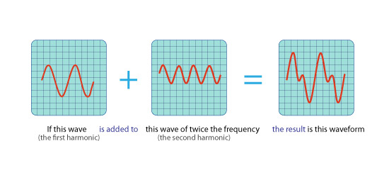

**C**

**B**

**A**

**⊕**

Compare A, B, and C.

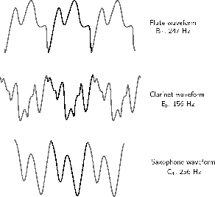

Flute waveform Clarinet waveform Saxophone waveform

**NOISE AND MUSIC**

* While the difference between noise and music can sometimes be very subjective, in general, the following definitions apply:

**Music:**

* Vibrating body vibrates with regular frequency and a definite pitch. Usually pleasant to the ear.

**Noise:**

* Body that produces vibrations that do not have a regular frequency. Usually unpleasant to the ear.

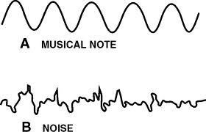

The intensity of a wave decreases in an inverse square relationship with distance from a point source.

*This includes applying the relationship*



# Intensity

* Waves are all about the transmission of energy through a medium.
* **Energy** : unit = Joule. Cannot be created or destroyed - only turned from one form into another.
* **Power** = energy flowing through a system in a given time: unit = J s-1 or Watt.
* In work on waves, we often make use of another concept related to energy:

**Intensity** = energy flowing through a certain area in a given time : unit = J s -1m-2 or W m-2

* Intensity is the amount of wave power flowing through a square metre, perpendicular to the direction of wave travel.
* If it is possible to measure the power of a source of wave energy and over what area this power spreads out, it is possible work out the intensity of the wave at any point around that area.

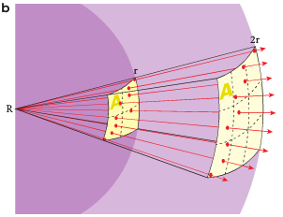

* If you were standing next to the light-bulb as it smashed, we'd expect to be hit by glass...but if we were a long way away we might not get hit by glass.
* The glass would spread out in a spherical pattern

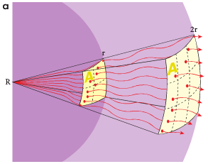

* If you were standing next to the light-bulb as it smashed, we'd expect it to be pretty loud...but if we were a long way away we might not hear it at all.

# The inverse-square law

* The inverse-square law is very important in physics.
* It explains why gravity gets less as you move away from a massive object and why sounds are loud close to the source but get softer as you move away.
* When an object creates a wave, a certain amount of energy is used.
* Close to the source, the energy is more intense. Far away from the source, the energy is less intense.
* The energy from the source is always the same - it is simply distributed over a larger area, the further away from the source you try to measure.
* 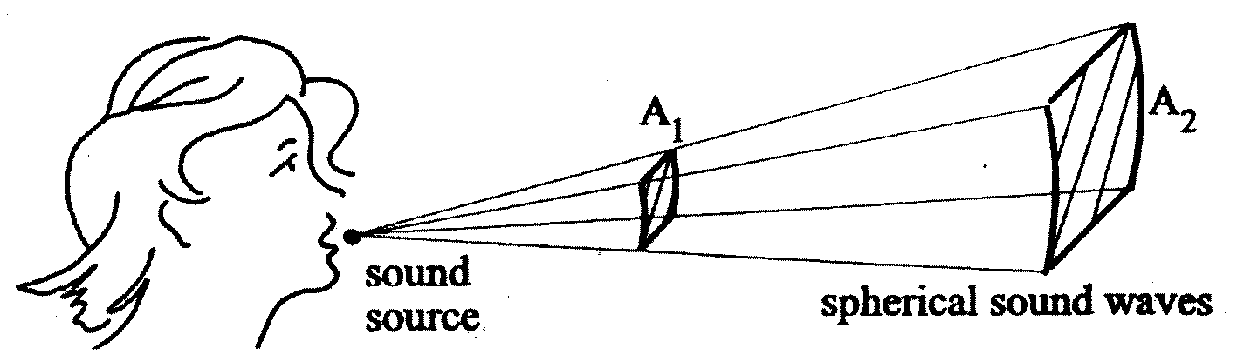The inverse square law relates to the area over which the power spreads out.
* Assume the power spreads out equally in all directions.
* The area is the surface of a sphere.
* At a distance r from the source, the power P of the source passes through an area 4πr2 - the surface area of a sphere radius r.

A = 4πr2

so (∝ = proportional to)

* Moving 10 metres away from a source will reduce wave intensity by a factor of 102 = 100.
* Sound energy is radiated uniformly in all directions from a small source at a rate of 1.5 W.

What is the intensity of the sound at a point 30 m from the source?

* A siren produces 6.50 joules of acoustical energy each second for a sound of 4500 Hz.

1. If the sound waves produced are considered spherical, compare the sound intensity levels at 2.00 m and 20.0 m from the siren. (Note: the surface area of a sphere = 4r2).
2. If another identical siren was sounded simultaneously with the original, what would be the sound intensity level at 20.0 m from both sirens?

**PP 10.6 p 380-6 10.6 Review p 387 WSG p135-6**

**PP Chapter review p 388-9 Unit 2 Review p 414-7**

**QUESTION SET ONE: Waves and Wave Behaviour.**

1. An umpire blows his whistle when he is at the opposite end of a football ground from you. Estimate the time delay between the moment you see the whistle being blown and when you hear it.

**s = 100 m (between 100 and 200 m OK) v = s/t**

**v = 346 m s-1 t = s/v**

**= 100/346**

**t = 0.29 s only 2 sf**

***(time for light about 3.33 x 10-7s so can ignore)***

**make sure you have no more than 2 significant figures in answer**

1. a. What does the term “displacement” mean when applied to sound waves (2000 TEE)

***Distance from mean position of a vibrating object, amplitude of vibration.***

b. Sketch graphs of displacement versus time for a low pitch graph and a high pitched graph.

**The assumption is that the amplitude is the same so only the wavelength changes.**

**A high pitch sound has a high frequency say 10 000 Hz and a low pitch sound has a low frequency say 100 Hz.**

**A displacement vs time graph show period.**

**T (high) = 1/10 000 = 1 x 10-4 s while T (low) = 1/100 = 0.01 s**

**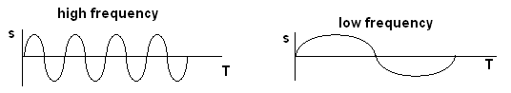**

1. Do sound waves diffract? If you wanted to try and demonstrate that your answer is correct, how would you try to do this? Include a diagram with your answer.

**Sound waves do diffract e.g. standing beside an open door, hear what is happening inside. Here the wavelength is a similar size to the opening (door) so very small shadow region and large diffraction.**

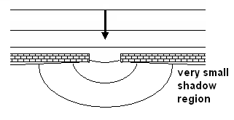

1. Some examples of waves are sound, radio, water waves, and X-rays. Classify these as either mechanical or electromagnetic waves

***Electromagnetic – radio and X-rays. Mechanical – sound and water waves***

1. A person fishing from jetty notices that the foam float on their fishing line gently bobs up and down as regular waves pass by. The person counts 13 full oscillations of the float in one minute. What is the period of the wave? (1998 TEE)

***f = 13/60 T = 1/f = 1/0.217***

***= 0.217 s T = 4.6 s***

1. An example of a longitudinal wave is ***sound***  An example of a transverse wave is ***light***

Explain the difference between longitudinal and transverse waves. (1998 TEE)

***Vibrations in longitudinal waves are parallel to the progression of energy of the wave.***

***Vibration in transverse wave are perpendicular to progression of energy of the wave.***

1. 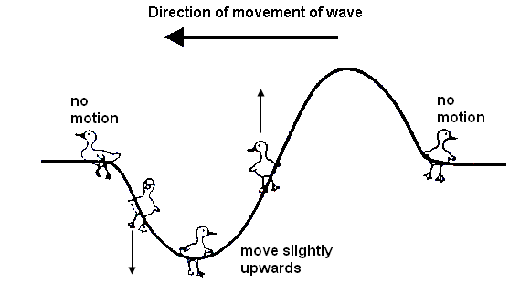Bridgette is watching some ducklings, which are paddling on a pond, when a wave approaches them. Use arrows to show direction of movement of each duckling at the instance shown on the diagram. If there is no movement, label “no-motion”.
2. Draw a graph to illustrate amplitude and wavelength of a wave.

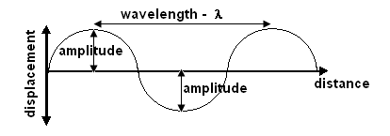

1. Complete the following diagram to show reflection of sound from a circular reflector.

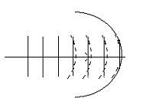

1. On a calm summer evening the air near the ground is rather cool while higher up it is warmer. Sound travels faster in warm air. Using wave-front diagrams carefully show how refraction of sound can allow the noise from an aircraft to be heard quite clearly at some point far away.

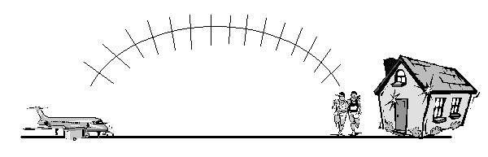

***As cooler lower down, the sound bends away from the normal as it moves upwards from the aircraft as it moves faster in warmer air. This creates the bending effect.***

**QUESTION SET TWO: Standing Waves, etc.**

(Unless told otherwise, use speed of sound in air as 346 m s-1)

1. Why is it important that the currents supplied to two loud speakers in a stereo pair are in phase?

**While in phase, the sound is reinforced. If out of phase, additional sound effects could be heard such as “dead spots” due to constructive and deconstructive interference.**

1. 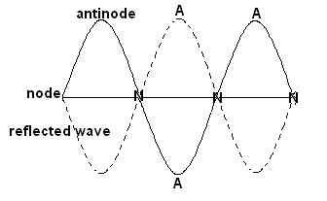Draw a diagram showing a guitar string vibrating in its third harmonic. Label the nodes and antinodes.
2. Copy and draw in the resultant wave.

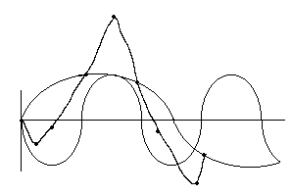

1. A guitar sting is 0.700 m long and is played so that it vibrates in its fundamental frequency. What would be its wavelength if it were played so as to vibrate in its 5th harmonic?

** = 0.700 m  f5 = 5 x 247.14**

**λ = 2 x 0.7 = 247.14 Hz = 1236 Hz**

**= 1.40 m = 1.24 x 103 Hz**

1. On a day when the speed of sound is 343 ms-1, a source emits sound of wavelengths 2.80 m and 3.10 m in air. How many beats per second will be heard?

** **

**= 122.5 Hz = 110.6 Hz**

**f beats = | 122.5 – 110.6 |**

**= 11.85**

**so 12 beats heard**

1. Explain the difference between natural and forced vibrations. Include examples with your answer. How is this related to resonance?

**Natural is when a body vibrates in its own natural frequency e.g. a tuning fork will vibrate at its own frequency.**

**Forced vibration is when an object is forced to vibrate in a frequency that is not its own natural frequency e.g. a tuning fork placed on a desk . the desk is forced to vibrate at the frequency of the tuning fork and the sound heard (large surface to vibrate compared to tuning fork).**

**Resonance is where an object is forced to vibrate but the vibrations match those of the object – its own natural frequency. Here are vibrations are greatly increased.**

1. Two identical tuning forks are set up on boxes open at one side as shown below with the open sides facing each other. The first tuning fork is struck, then stopped from vibrating. A listener notices that the second tuning fork is now sounding even though the two boxes are not touching. Name and explain this phenomena.

**Resonance.**

**The vibrating air in the first sounding box causes the air in the second box to also vibrate which in turn causes the second tuning fork to vibrate. As the tuning forks are matched, the forced vibrations are the same as the natural vibrations so they are greatly increased and we hear the second tuning fork.**

1. A large organ pipe is 2.20 m long and open at both ends. Find its fundamental frequency.

**λ = 2 x  **

**= 2 x 2.20 f = 78.6 Hz**

**= 4.40 m**

1. The shortest length of a tube, closed at one end, which resonates to a tuning fork of frequency 326 Hz is 0.260 m.
   1. What is the wavelength of the note emitted by the fork?
   2. What is the speed of sound in air in this case?

**a. λ = 4 b. v = fλ**

**= 4 x 0.26 = 326 x 1.04**

**= 1.04 m = 339.04**

1. A crude whistle can be made by drilling some holes in a cylinder of metal and flattening one end to act as a mouthpiece. The mouthpiece acts as a closed end while the other end can be considered to be open. The instrument is played in a room in which the temperature is 250C.
   1. With all the holes covered the whistle produces a fundamental note of 152 Hz when blown gently. What is the wavelength of the fundamental note?

** 2.28 m**

* 1. What is the effective length of the whistle?

**= ¼ λ**

**= ¼ x 2.28**

**= 0.570 m**

* 1. When the fundamental note is sounding at which position (mouthpiece end, open end or halfway along the whistle) would the amplitude of vibration of the air molecules be at its maximum?

**maximum vibration at antinode so therefore at open end**

* 1. What is the wavelength of the third harmonic played on the instrument?

** OR f3 = 3 x 152 = 456 Hz**

**λ = 0.760 m m**

1. The distinguishing quality of the human voice depends on the presence of harmonics (or formants) in the sound spectrum.
   1. What are harmonics?

**Harmonic are higher frequencies of a fundamental standing wave.**

* 1. The closed pipe is used as a model for the human vocal system. If you produce a vocal sound having a fundamental frequency of 665 Hz, what will be the frequencies of the next two higher harmonics?

**ff = 665 Hz as closed pipe, odd harmonic so**

**next = 3 x 665 = 1995 Hz**

**then = 5 x 665 = 3325 Hz**